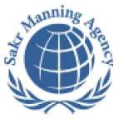 | SAKR MANNING AGENCY  FOR RECRUITING EGYPTIAN LABOR ABROAD | Issue Date | 15.05.2022
 | SAKR MANNING AGENCY  FOR RECRUITING EGYPTIAN LABOR ABROAD | Revision Date | 27.05.2023
 | Crewing Management Manual  Seafarer Employment Application | Revision | 1.2
 | Crewing Management Manual  Seafarer Employment Application | Page | 3
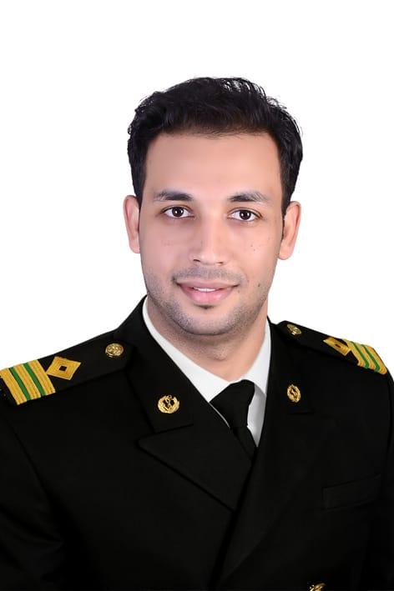
Application For Position as | ETO
Register Code. | EO-4.059
Other Position (If Any) | ELECTRIC ENGINEER
Register Date | 09.03.2026
Last up Date Data
Expected Salary | 5000

1. PERSONAL DETAILS
Full Name |  | WALID MEDHAT HASSAN MUHAMMED HASSAN KHALIL
Date Of Birth |  | 01/01/1998 |  |  |  |  |  |  | Place Of Birth |  |  |  |  |  |  |  | ALEXANDRIA-EGYPT
Nationality |  | EGYPTIAN |  |  |  |  |  |  | Marital Status |  |  |  |  |  |  |  | Single |  |  |  |  |  |  |  | Married
Height (Cm) |  | 174 |  |  |  |  |  |  | Overall Size |  |  |  |  |  |  |  | M |  |  |  |  | Shirt Size |  |  |  |  |  | M
Weight (Kg) |  | 70 |  |  |  |  |  |  | Trouser Size |  |  |  |  |  |  |  | 31 |  |  |  |  | Shoes Size |  |  |  |  |  | 42
2. EDUCATION
College / School |  | Bachelor of Engineering Electrical Power Department (Alexandria university)
Marline Test |  | Issued Date |  |  |  |  | Result % |  |  |  | Issued By (Authority) |  |  |  |  |  |  |  |  |  | Issued At
English Language |  | Fluent |  |  |  |  |  | Good |  |  |  |  | Average |  |  |  |  |  |  |  | Poor
French Language  ( ) |  | Fluent |  |  |  |  |  | Good |  |  |  |  | Average |  |  |  |  |  |  |  | Poor
3. CONTACT DETAILS
Home Address / City |  |  | MUHARRAM BEK-ALEXANDRIA-EGYPT
E-Mail |  |  | WALID.MEDHAT.HASSAN@GMAILCOM |  |  |  |  |  |  | Mobile / Tel |  |  |  |  |  | +201027167863

4. TRAVEL DOCUMENTS
Type |  | Document No. |  |  |  | ISS. Date |  |  | Exp. Date |  |  |  |  | ISS. By (Authority) |  |  |  |  |  |  |  |  |  | Place of Issue
Passport |  | A35036643 |  |  |  | 06/09/2023 |  |  | 05\09\2030 |  |  |  |  | Egyptian Authority |  |  |  |  |  |  |  |  |  | OFFICE 18
Seaman Book |  | S00062254 |  |  |  |  |  |  | 25/01/2031 |  |  |  |  | EAMS |  |  |  |  |  |  |  |  |  | Alex.
Other Seaman Book

5. PROFESSIONAL QUALIFICATION / CERTIFICATE OF COMPETENCY
Certificate Name |  |  |  |  | Number | Issue Date |  |  |  |  |  | Expiry Date |  |  |  |  |  | Issued By |  |  |  |  |  |  |  |  | Issued At
COC ( Rank) ETO |  |  |  |  |  |  |  |  |  |  |  |  |  |  |  |  |  | EAMS |  |  |  |  |  |  |  |  | Alex.
GOC
D.P. INDUCTION
D.P. ADVANCED
D.P. OPERATOR (UNLIMITED)
6. NEXT OF KIN
Full Name | MEDHAT HASSAN MUHAMMED HASSAN KHALIL |  |  |  |  |  |  |  |  |  |  |  |  |  | Relationship |  |  |  |  | FATHER
Address | MUHARRAM BEK-ALEXANDRIA-EGYPT
Tel. No. |  |  |  |  |  |  |  |  |  | Mobile |  |  | 01095023204 |  |  |  |  |  |  |  |  |  | 0108887218
7. HEALTH CERTIFICATES & VACCINATIONS
Flag State |  |  |  | Number |  |  | Issue Date |  |  |  |  | Expiry Date |  |  |  |  |  |  | Issued By |  |  |  |  |  |  | Issued At
International Medical |  |  |  |  |  |  |  |  |  |  |  |  |  |  |  |  |  |  | EAMS |  |  |  |  |  |  | Alex.
Yellow Fever |  |  |  |  |  |  | 09/10/2023 |  |  |  |  | For Life |  |  |  |  |  |  | Ministry of Health
Cholera |  |  |  |  |  |  | 09/10/2023 |  |  |  |  | For Life |  |  |  |  |  |  | Ministry of Health
Covid-19 |  |  |  | Vaccination Name |  |  | First Dose |  |  |  |  | Second Dose |  |  |  |  |  |  | (Other Does or Remarks)
 |  |  |  | Sputnik V |  |  | 10/10/2021 |  |  |  |  | 31/10/2021

8. MARINE COURSES
Course Name | Number | Issue Date | Expiry Date | Issued By / At
Personal Survival Techniques
Proficiency In Personal Survival Techniques | 4021/26/EG | 01-02-2026 | 25/01/2031 | AASTMT
Fire Prevention and Fire Fighting
Advanced Fire Prevention and Fire Fighting | 5540/26/EG | 08-02-2026 | 04/02/2031 | AASTMT
Elementary First Aid | 5718/26/EG | 08-02-2026 | 04/02/2031 | AASTMT
Medical Care Studies
Personal Safety and Social Responsibilities | 3729/26/EG | 01-02-2026 | 28/01/2031 | AASTMT
Proficiency Of Security Awareness Training Seafarers | 4265/26/EG | 02-02-2026 | 27/01/2031 | AASTMT
Proficiency as a ship Security officer ( PSSO )
Proficiency In Survival Craft & Rescue Boats | 3899/26/EG | 01-02-2026 | 28/01/2031 | AASTMT
G.M.D.S.S
Communications
Advanced Communications
ECDIS Advanced Simulator (Management Level)
ECDIS Simulator (Operation Level)
Prevention and Combating of Marine Pollution | 6257/26/EG | 11-02-2026 |  | AASTMT
Radar & ARPA Simulator and Search &rescue
ARPA Simulator and Search
Marine Radar and automatic Radar Plotting
Bridge resource Management (B.R.M)
Engine resource Management (E.R.M)
Navigational Watch keeping
Proficiency for Rating forming part of Navigational watch (II/4)
High voltage training – operation of ship (1000 Volt and More) | 42403/25/EG | 02-10-2025 |  | AASTMT
Passenger Safety Cargo Safety and Hull integrity
Crowd Management Training
Crisis Management and Human Behavior Training
Safety training for Personal Prov. Direct Passengers
Practical Ability to Prepare Meals and (MLC 2006)
Personal Hygiene and Envir. Protection (MLC 2006)
Safety and Health in the Provision Meals (MLC 2006)
Food Storage and inventory Control (MLC 2006)
Ships Cook Certificate (MLC 2006)
Abel Seafarer Deck
Proficiency for Abel Seafarer Deck ( II/5 )
Engineering Watch keeping
Proficiency for Rating forming part of a watch in engine room
Abel Seafarer Engine
Proficiency for Abel Seafarer Engine ( III/5 )
Electro Technical Rating
Proficiency for Electro Technical rating ( III/7 )

 |  |  | COMPLETE SEA – SERVICE DETAILS
Name: |  |  |  |  |  |  |  |  |  | Rank: |  |  |  | Register Code:
Company Name |  |  |  | Rank | Vessel Name | Flag |  | Signed On |  |  |  | Signed Off |  | Period | Vessel Type |  | D.W.T. |  | Engine Type |  | BH |  |  | KW
REK NAV |  |  |  | Electric Engineer | Rek R | palau |  | 21/10/2023 |  |  |  | 28/09/2024 |  | 11 MONTH | Bulk Carrier |  | 16856.7 T |  | MAN B&W 6L35 MC |  | 5230 HP |  |  | 3900 KW
REK NAV |  |  |  | Electric Engineer | Rek Royal | panama |  | 02/12/24 |  |  |  | 06/08/2025 |  | 8 MONTH | Bulk Carrier |  | 20035 T |  | MAN B&W 8S35 MC |  | 7936 HP |  |  | 5920 KW
 |  | SPECIALISED EXPERIENCE
 |  | Name |  |  |  |  |  |  | Type |  |  |  | From |  |  | To |  | Comments
 |  | I declare that the information I have given is, to the best of my knowledge, true and complete. I also declare that the documents submitted are genuine, given and sign by persons whose names appear on them.

